**SELECT, GROUP BY, AGGREGATE FUNCTION**

1. **Create following table. And insert following data**

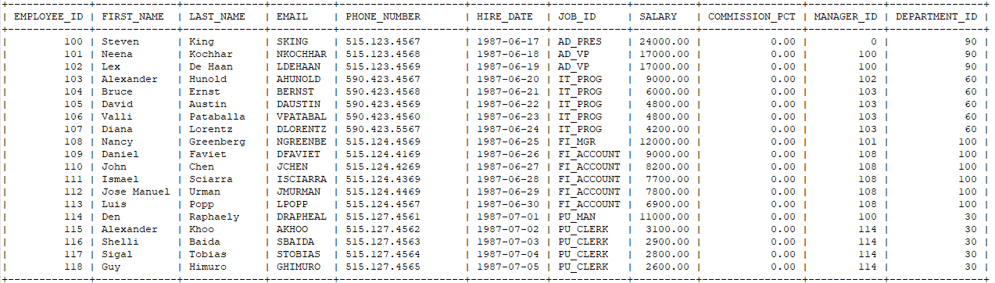

**Solution:**

1. **Write a query to display the names (first_name, last_name) using alias name “First Name", "Last Name**

SELECT FIRST_NAME AS "FIRSTNAME", LAST_NAME AS "LASTNAME" FROM Customers;

1. **Write a query to get unique department ID from employee table-**

SELECT DISTINCT DEPARTMENT_ID FROM Customers;

1. **Find total the number of employees in the table.**

SELECT COUNT(EMPLOYEE_ID) AS TOTAL_EMPLOYEES FROM Customers;

1. **Write a query to display the number avg salary of all employees.**

SELECT AVG(SALARY) AS AVARAGE_SALARY FROM Customers;

1. **Write a query to display the number avg salary of all employees from each department.**

SELECT DEPARTMENT_ID, AVG(SALARY) AS AVARAGE_SAL_DEPARTMENTWISE FROM Customers

GROUP BY DEPARTMENT_ID;

1. **Write a query to display the number sum salary of all employees.**

SELECT SUM(SALARY) AS SUM_SALARY_OF_ALL_EMPLOYEES FROM Customers;

1. **Write a query to display the number sum salary of all employees from each department.**

SELECT DEPARTMENT_ID, SUM(SALARY) AS SUM_SALARY_DEPARTMENTWISE FROM Customers

GROUP BY DEPARTMENT_ID;

1. **Write a query to display all the employes with last name being sort in descending order.**

SELECT LAST_NAME FROM Customers

ORDER BY LAST_NAME DESC;

**10.Write a query to display all the employees has character e in their first name.**

SELECT FIRST_NAME FROM Customers

WHERE FIRST_NAME LIKE '%e%';

**11.Write a query to display all the employees has character 2 characters a in their last name.**

SELECT LAST_NAME FROM Customers

WHERE LAST_NAME like '__';